Fuel Level Gauge – LPG - CGEA 1.3

Functional Description

This STSS is intended for a mechanical (Stepper Motor) analog Alternative Fuel Gauge. (i.e. a re-purposed ECT gauge). It looks identical to a traditional gasoline (petrol) or diesel fuel gauge, it is just labeled “LPG” or “CNG”. The assumption is that this gauge is shown all the time, and has a separate end-item part number. The gauge is driven via a filtered CAN signal from the AFCM (Alternative Fuel Control Module). The AFCM is typically either for LPG (Liquid Propane Gas) or CNG (Compressed Natural Gas).

Since the first application of this STSS is for LPG, we will show LPG graphics, etc. Just realize this could be applied to CNG as well.

The purpose of the LPG Fuel Gauge is to display the LPG fuel level.

The LPG Fuel Gauge correlates the AltFuelLvl_Pc_Actl and AltFuelLvl_D_Stat signals, and the Operational Mode to generate a needle position.

Interfaces

Interface Context Diagram (I/O Block Diagram)

Figure 1 LPG Fuel Gauge Context Diagram

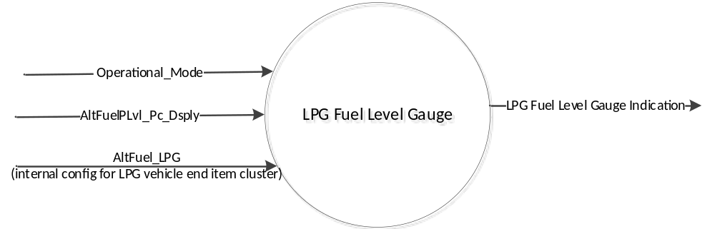

Inputs

- Internal:
- Operational_Mode
- AltFuel_LPG (Internal cluster config per end item)

- MUX signals on the CAN Bus

Table 1.0 – AltFuelPLvl_Pc_Actl Signal
Signal Name | Size (bits) | Detail | Units | Res. | Offset | State Encoded | Min | Max
AltFuelPLvl_Pc_Actl | 8 | LPG Level Indicator | % | 0.471 | 0 |  | 0  (0x0) | 120.105 (0xFF)

Table 1.1 – AltFuelLvl_D_Stat Signal
Signal Name | Size (bits) | Detail | Units | Res. | Offset | State Encoded | Min | Max
AltFuelLvl_D_Stat | 1 | No fault | SED | 1 | 0 | (0x0) | 0  (0x0) | 1  (0x1)
 |  | Fault |  |  |  | (0x1)

Outputs

LPG Fuel Level Gauge Indication -- analog gauge pointer value

Function/Performance

Operational Modes

Mode | Differentiating Vehicle Conditions
Sleep Mode | LPG Fuel Level Gauge pointer at ‘Rest Position’
Limited Mode | LPG Fuel Level Gauge pointer at ‘Rest Position’
Normal Mode | LPG Fuel Level Gauge pointer at “LPG Fuel Level Gauge Indication”
Crank Mode | LPG Fuel Level Gauge pointer at “LPG Fuel Level Gauge Indication”

Operational Modes Voltage Levels

Refer to the Cluster Features table located in the Operational Modes and Voltage Range Strategies Section of this SPSS.

Human-Machine Interface

Visual

Indicator Graphics / Display Format

Reference Cluster Graphic only. Use Program Specific Graphics from Ford Studio.
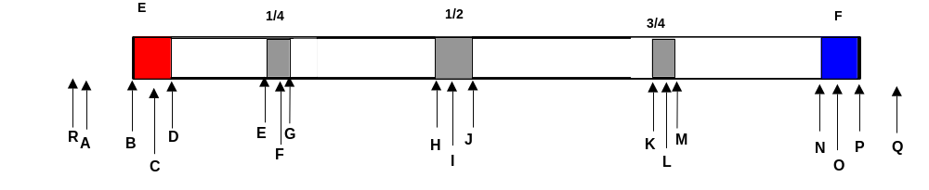
Example:
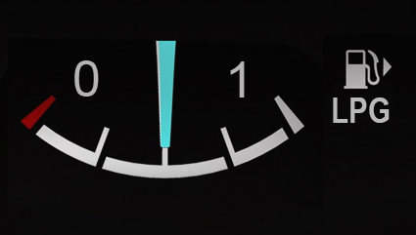

Gauge Position |  | Description
A |  | E Stop
B |  | Up to 2° below center of E
C |  | Center of E
D |  | Up to 2° above center of E
E |  | Up to 1° below center of 1/4
F |  | Center Of 1/4
G |  | Up to 1° above center of 1/4
H |  | Up to 2° below center of 1/2
I |  | Center of 1/2
J |  | Up to 2° above center of 1/2
K |  | Up to 1° below center of 3/4
L |  | Center of 3/4
M |  | Up to 1° above center of 3/4
N |  | Up to 2° below center of F
O |  | Center of F
P |  | Up to 2° above center of F
Q |  | F stop
R |  | Rest Position/Diagnostic Position

Indicator Color Coordinates

As per studio approved design. Reference COLOR & ILLUMINATION REQUIREMENTS (GRAPHICS) section located in the Master Document section of this SPSS

Indicator Characteristics

Analog gauge displaying the vehicle’s indicated LPG Fuel Level.

Description of Gauge | Scale Range | Scale Span | Nominal Operating Span
North American (NA) | “E” to “F” | 0 – 86 angular degrees | -4 to 89 angular degrees
Non-NA | “0” to “1” | 0 – 86 angular degrees | -4 to 89 angular degrees

Audio

None.

Switch Control Logic

None

System Accuracy

- The LPG Fuel Level Gauge Indication value shall be calculated within 100 msec of receiving a valid CAN Signal value.
- For a steady state input, the LPG Fuel Level Gauge shall position its pointer on the input value with a tolerance of + / - 2 angular degrees.
- The LPG Fuel Level Gauge Indication shall not lag the CAN Signal Input by a time greater than 300 msec.
- The LPG Fuel Level gauge pointer shall traverse to at least 90% of the travel to rest position within 1000mS and complete travel to rest position within an additional 300mS when transitioning to "Sleep Mode" or "Limited Mode.

Operation: Performance and Functional

Subsystem Algorithm Flowchart / State Diagram

Figure 2: LPG Fuel Gauge Process

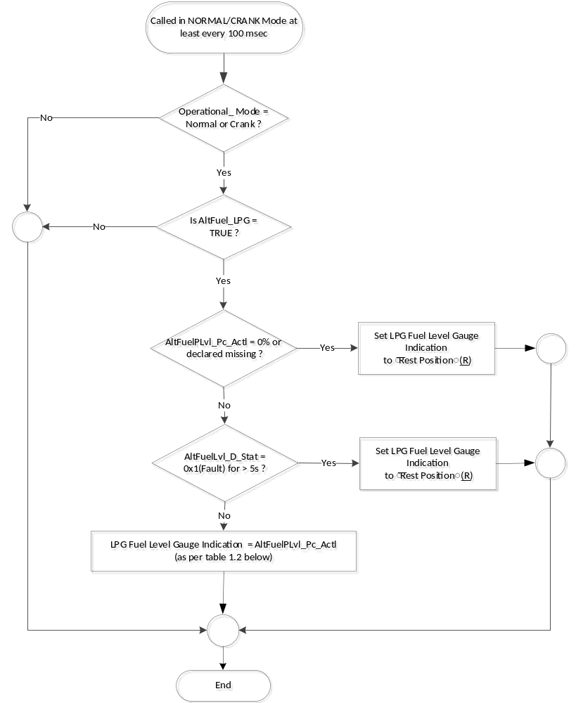

Table 1.2 LPG Fuel Indication
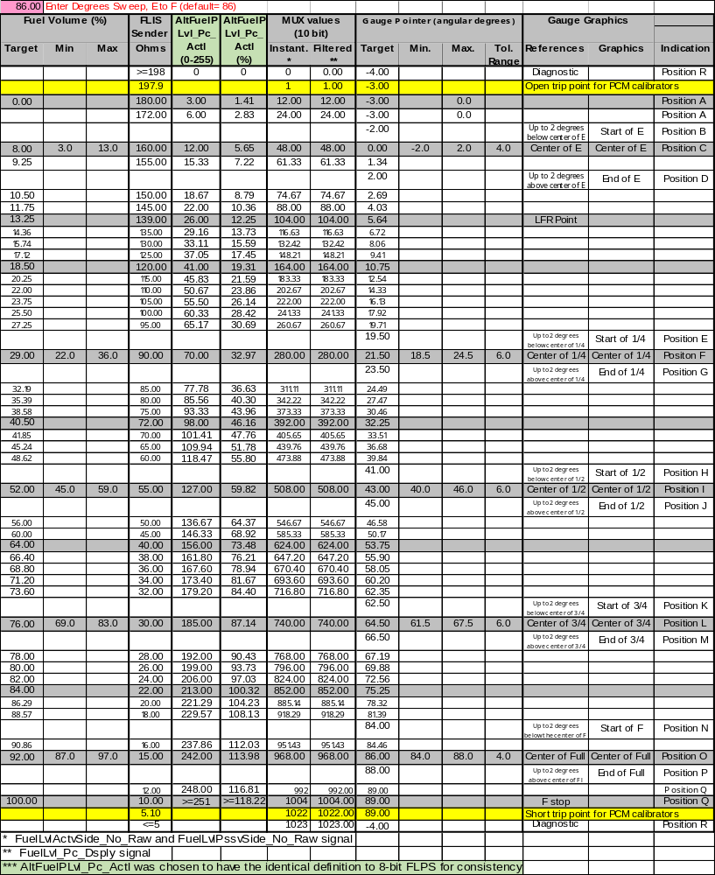

Operation Description (supports algorithm flowchart /state diagram)

- The LPG Fuel Level Gauge pointer movement shall be measurable in angular degrees and appears to be smooth and continuous.
- The LPG Fuel Level Gauge shall not exhibit needle waver exceeding 1/3 of an angular degree with a steady commanded input.
- Pointer overshoot and return to correct fuel level indication shall not exceed 1 angular degree.
- Gauge pointer shall move to “Rest” position at its fastest rate and within 2 seconds when:
- The key is positioned to OFF or ACC or
- Microprocessor executes a hardware reset

Function Safety Classification (EMC)

B

Memory Storage

Parameter Name | Description | Value at  Battery Connect | Value at  Module Wake-up
Operational_Mode | 4 state indicator for cluster operational mode | Limited | Limited, Normal or Crank
AltFuelPLvl_Pc_Actl | CAN signal sent from the AFCM to drive the LPG Fuel Level gauge | 0x0 | 0x0
LPG Fuel Level Gauge Indication | Used to control the LPG Fuel Level gauge pointer position. | 0 | 0
AltFuel_LPG | Internal cluster configuration for whether cluster end item is for a LPG equipped vehicle and has an LPG fuel level gauge (True or False). | Use Stored Value | Use Stored Value

Prove Out

None

Reconfigurable Telltale

None.

Message Center Msg

None

Error Handling
- The LPG Fuel Level gauge shall be “0” (Rest Position) when determining an error condition.

Missing Message Strategy

The signals will be declared missing as per the Diagnostics section of this SPSS.

DTCs states and history will be determined as per the Diagnostics section of this SPSS.

1.4.2 Invalid Message Strategy

None

Diagnostics

Self Test

The gauge shall sweep the full range & return to the “0” position prior to going to the desired indicated position.

Engineering Test Mode

Reference section “Dealer / Engineering Test Mode (ETM)”

Part II Performance
Supported Diagnostic Trouble Codes (DTCs)

DTC | Description
C10800 | Lost Communication With Alternative Fuel Control Module
C40982* | Invalid Data Received From Alternative Fuel Control Module
* Use whichever of these DTC’s is appropriate. C10800 is used if signal is part of a frame gateway message. C40982 is used if the signal is repackaged in the gateway with an Update Bit.

DID DExx
Block  Num | Block Description | Byte(s) | Bits | State: Description | "0" | "1" | Default | Comments/  Information
 | None

Reference Specification
- Instr. & Gauges (indic. Grad) IS-0015
- Gauge Durab. IS-0033
- Sys. Audible Noise IS-0103

Revision History
SPSS Module Revision History

Revision Level | Name | Change Description | Date
1.0 | S. Watkins | Initial Release. Lead program is B479 ICA. | 12/20/2017

